Lab Report

Your Information
Your Name: Joshua Zimmerman-Gibson
Assignment Title: Build a Storyboard in Tableau

Screenshots
Step 1.1: Import Data into Tableau Desktop
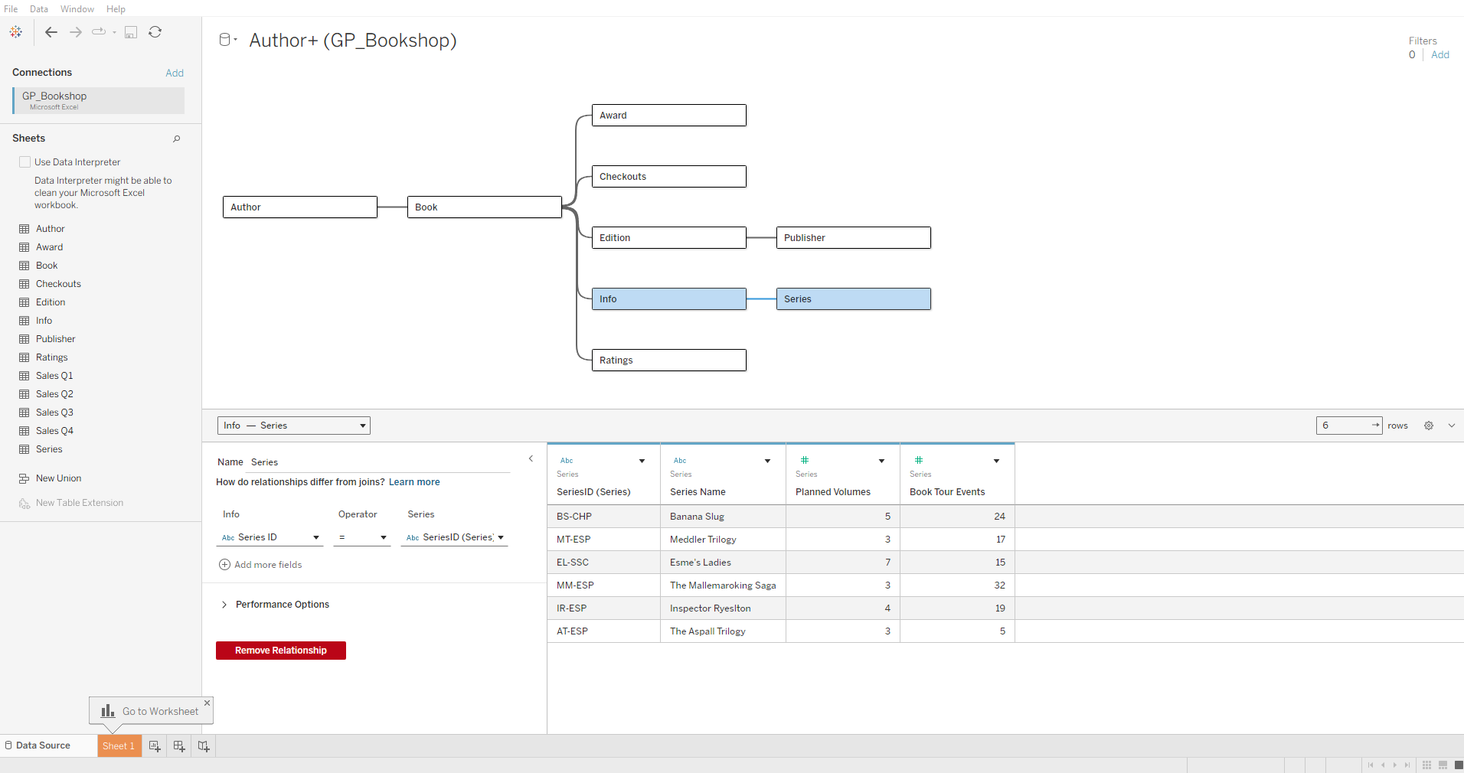
Step 1.2: Union the Quarterly Sales Data
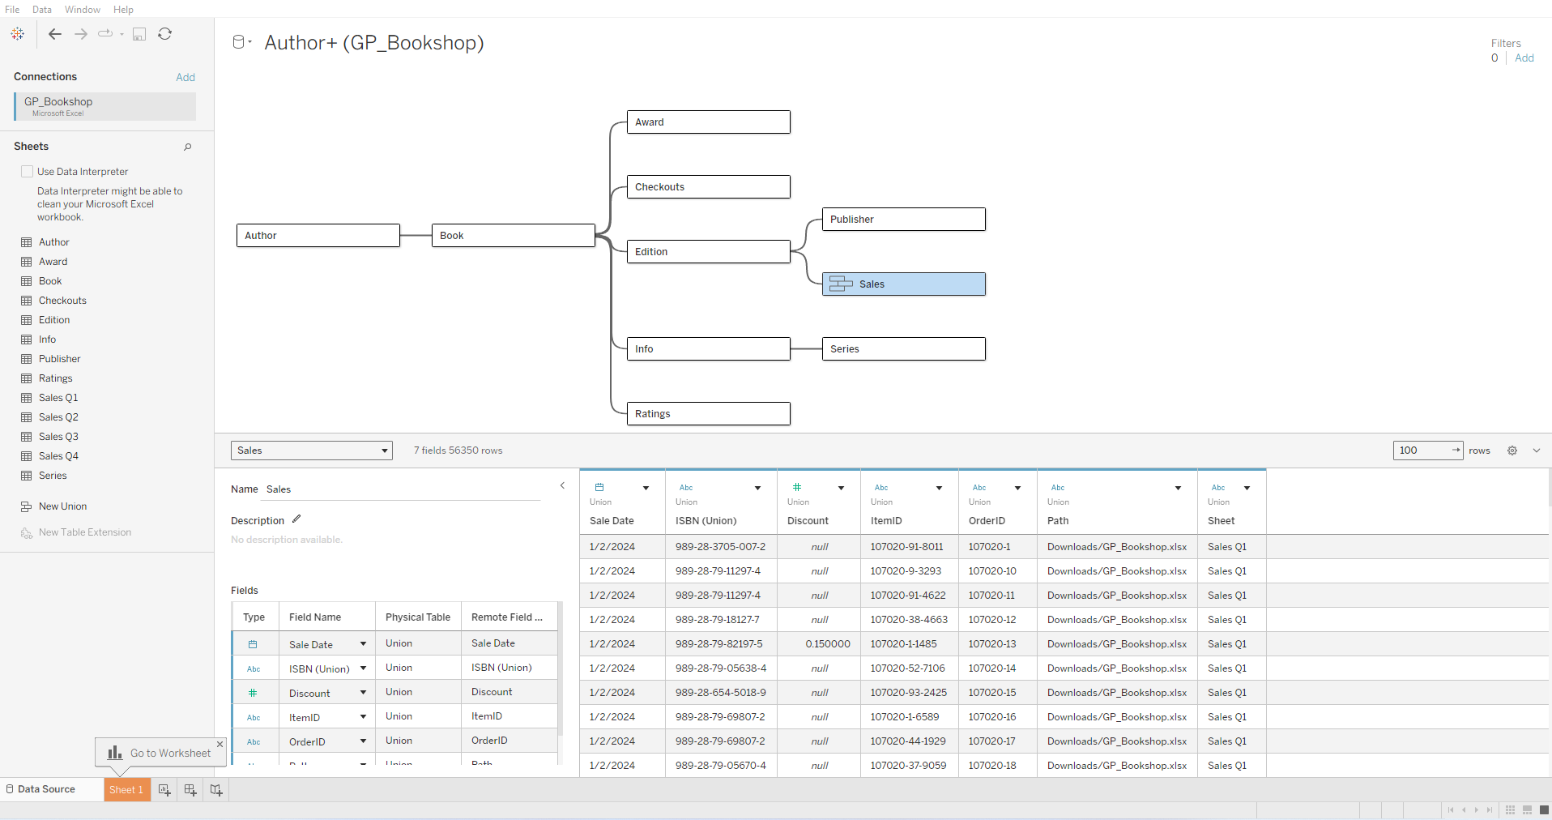
Step 1.3: Create a Calculated Field for StudentID
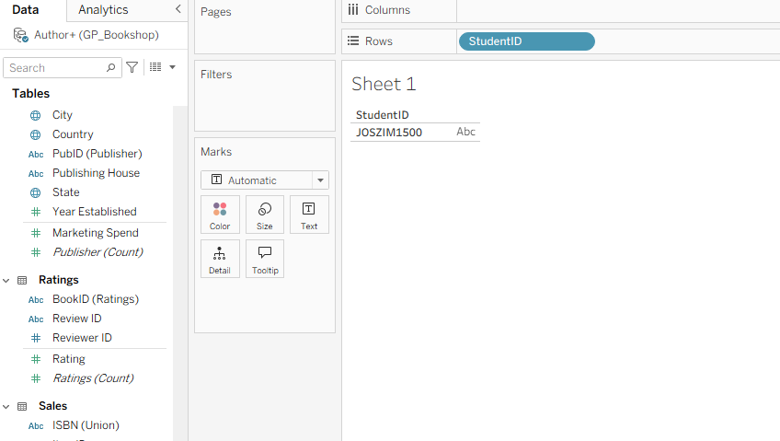
Step 1.4: Create a Calculated Field for Current Date and Time
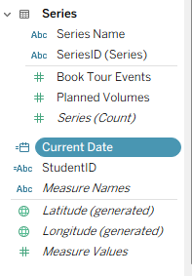
Step 2.1: Visualizing Overall Order Trends
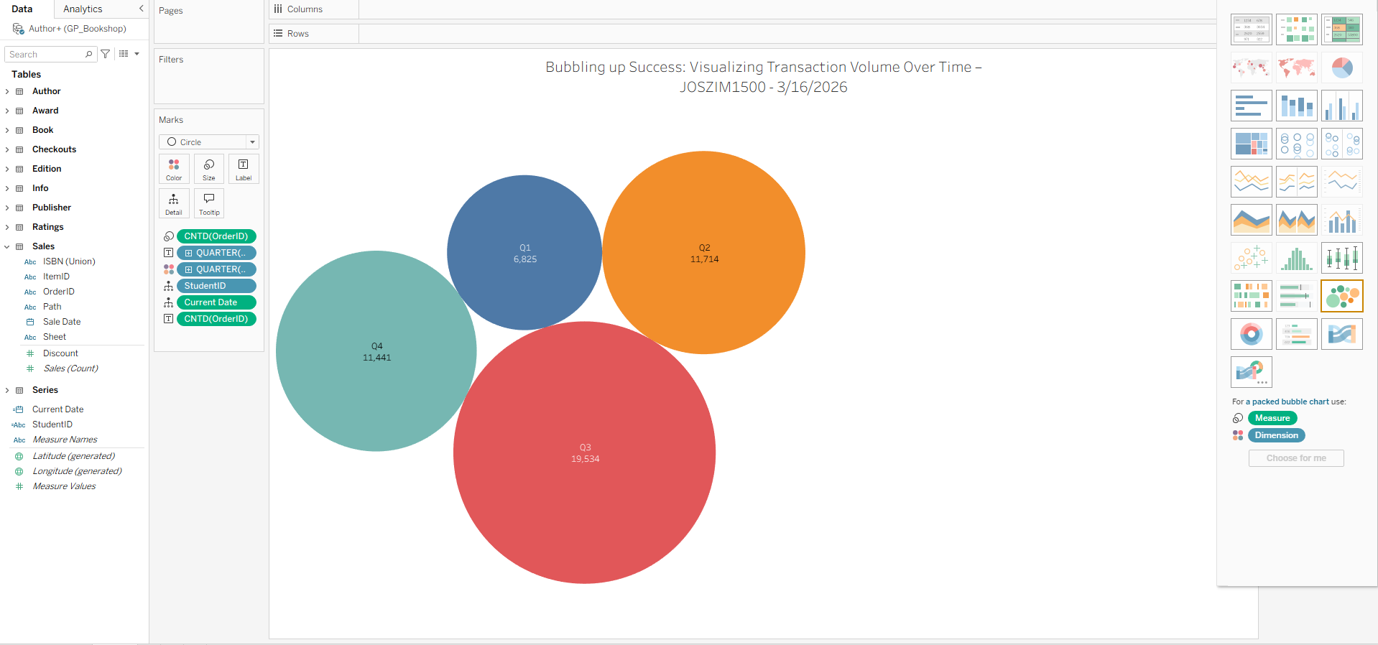
Step 2.2: Highlighting Top 5 Bestselling Books by Transaction Count
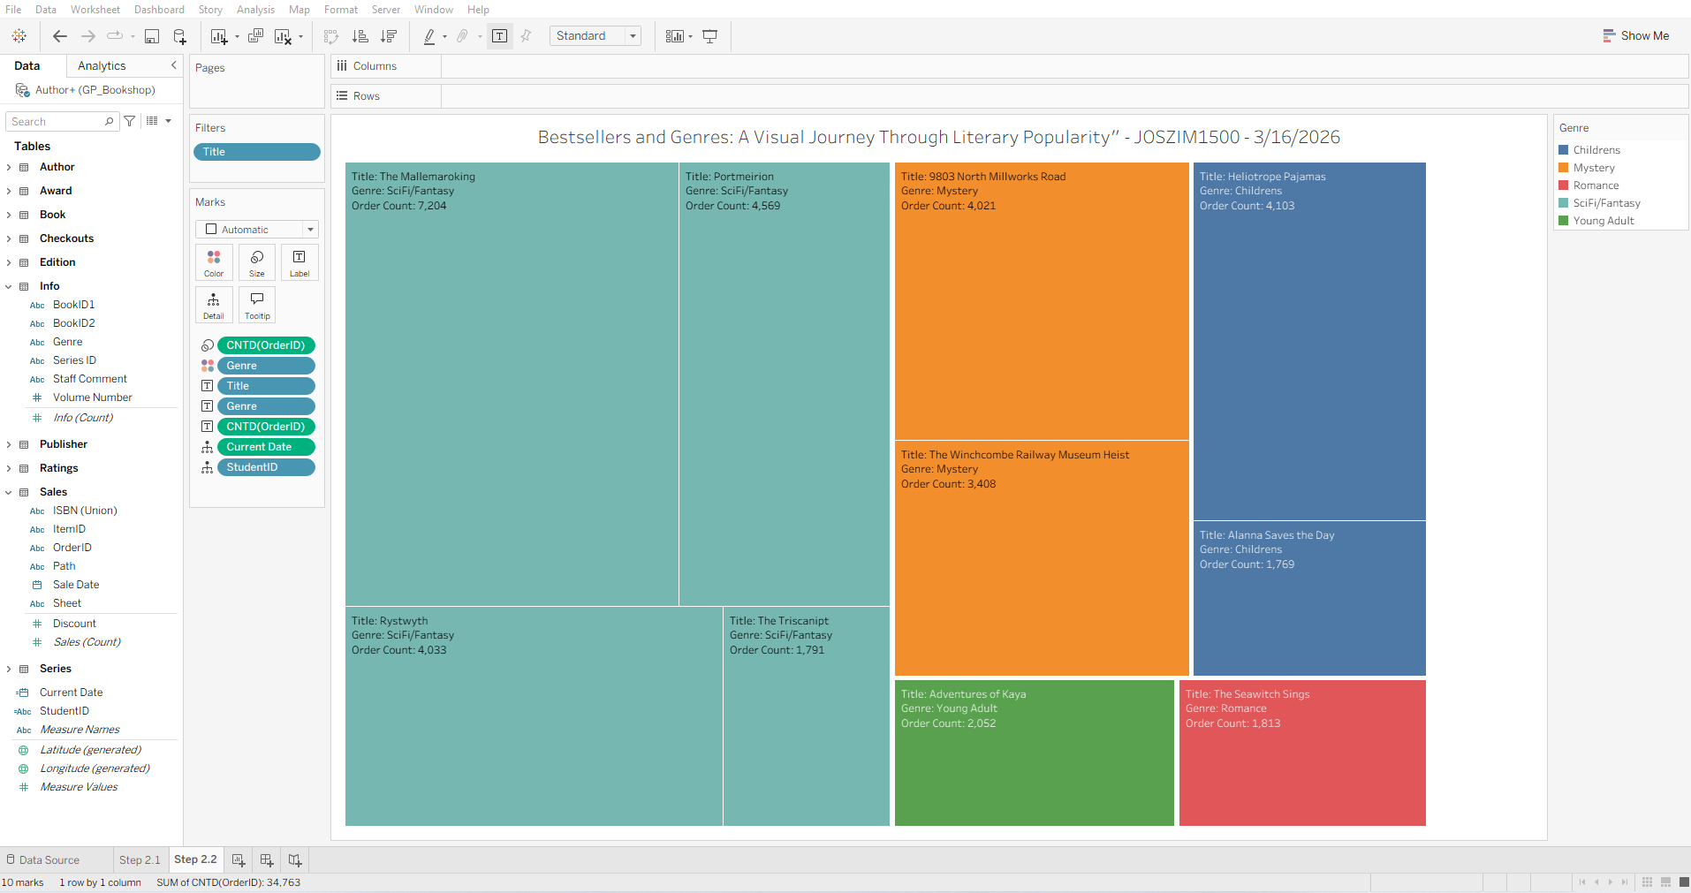
Step 2.3: Correlation between Ratings and Transaction Volume
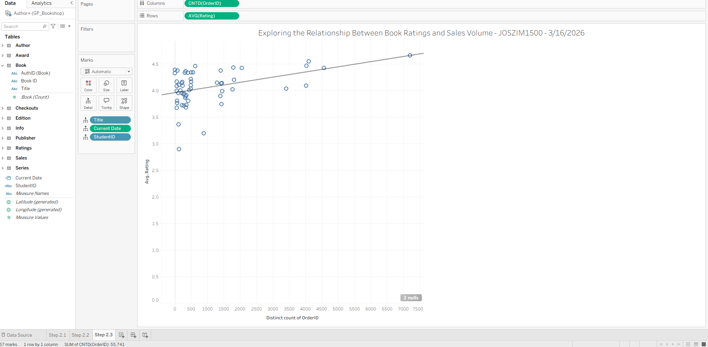
Step 3.1: Setting Up the Storyboard
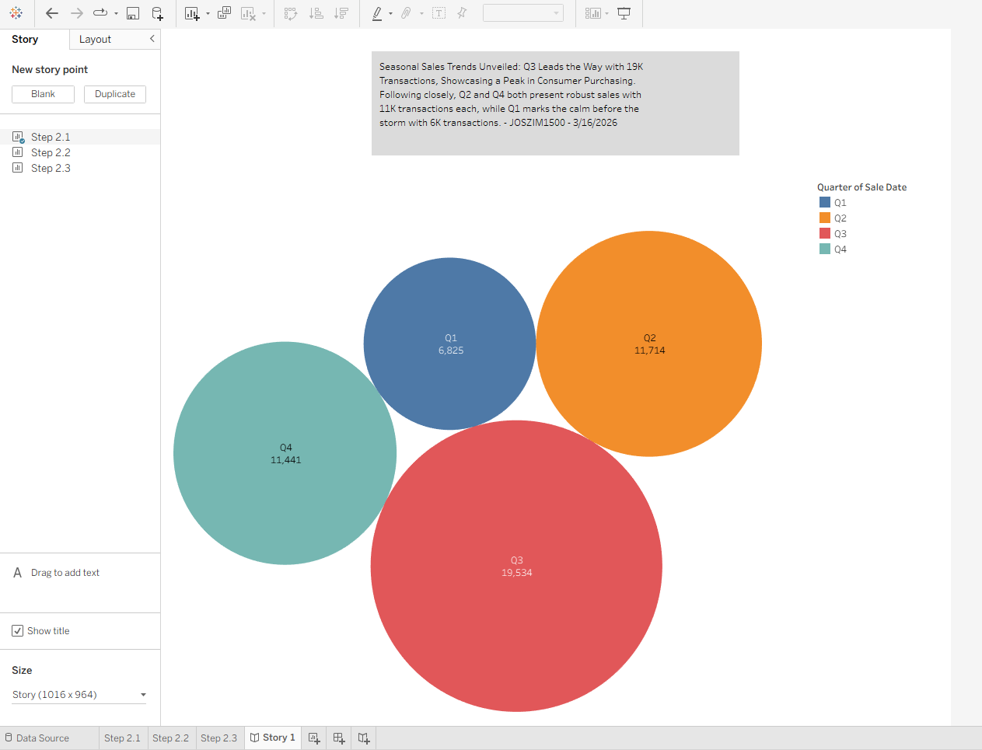
Step 3.2: Detailing Genre Popularity Over Time
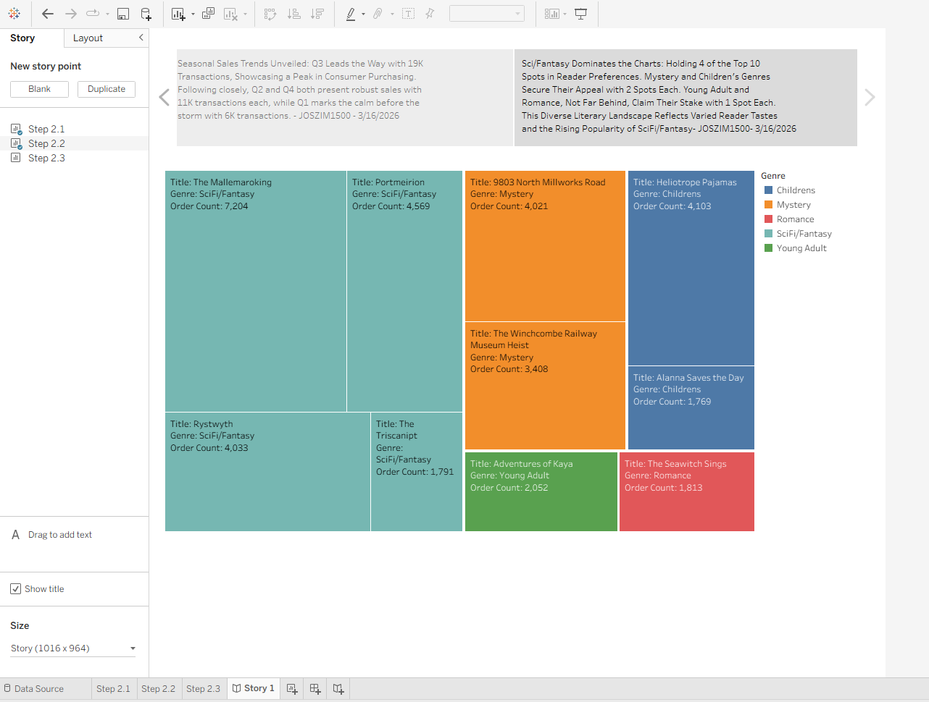
Step 3.3: Correlation Between Ratings and Sales
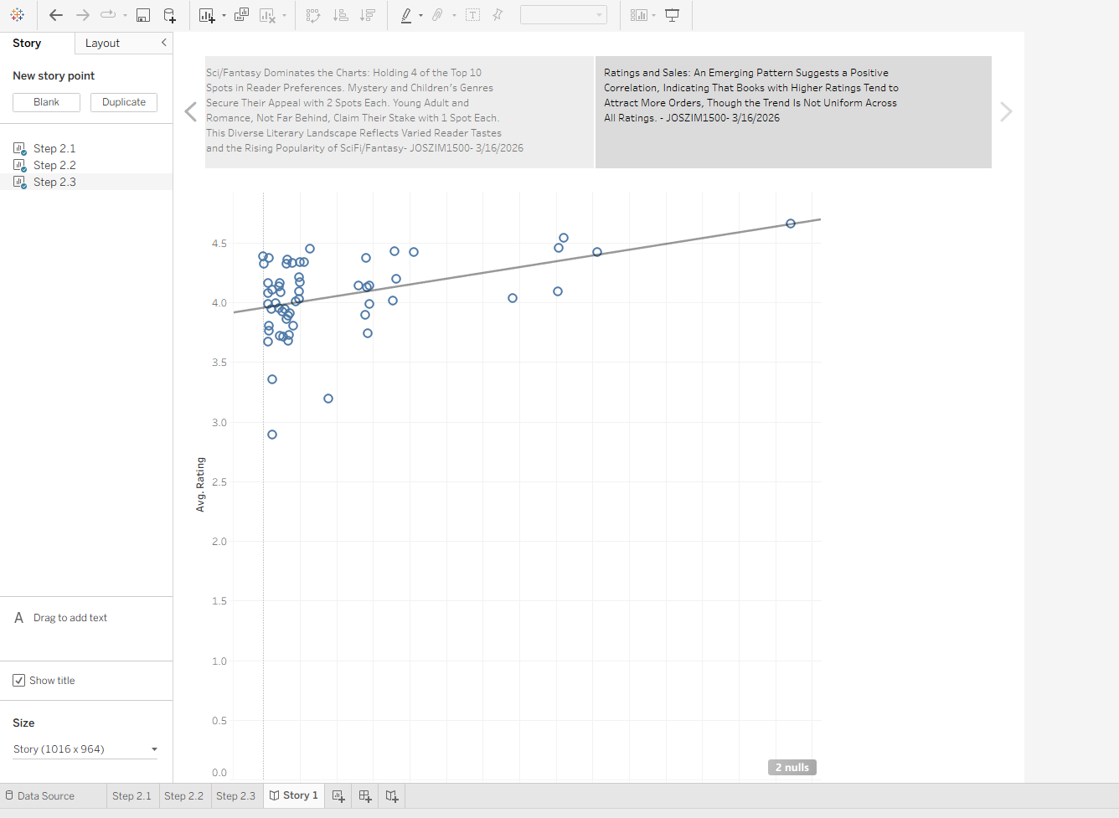

Questions
1. What does the visualization created in Step 2.1, using packed bubbles to represent total order
count, tell you about the relationship between quarters and sales volume?
The packed-bubble chart helps compare total order counts across quarters by using the size of each bubble to represent the volume of sales. With this type of visualization, it becomes easy to see which quarters noticeably higher activity had because their bubbles appear larger. Even though packed bubbles don’t show an exact trend over time like a line chart would, they still make it clear which quarters stand out and how the quarters compare to one another at a high level. Overall, the visualization highlights the relative differences in sales volume between quarters in a quick, visually intuitive way.
2. How does the tree map visualization created in Step 2.2, which shows the count of orders by
title and genre, assist in identifying trends in book sales?
The tree map groups books by genre and sizes each rectangle according to the number of orders, making it useful for spotting which genres and titles are the strongest performers. Larger blocks indicate higher sales, so patterns become easy to identify, such as which genres consistently generate more orders or which titles dominate within a genre. Because tree maps emphasize proportional relationships, they help reveal emerging trends, top-selling categories, and potential gaps in the catalog, all of which support better analysis of book-sales behavior.
3. Based on the scatter plot created in Step 2.3, how does the relationship between book ratings
and the number of orders illustrate the impact of customer satisfaction on sales?
In the scatter plot, each point represents a book, plotted by its rating and its number of orders. This type of visualization makes it easier to see whether higher-rated books tend to receive more orders. If the points generally slope upward from left to right, that suggests a positive relationship, meaning books with higher customer satisfaction (reflected by higher ratings) tend to sell more. Even if the relationship isn’t perfect, this visualization helps identify whether ratings influence purchasing behavior and supports the idea that customer satisfaction can impact sales performance.

